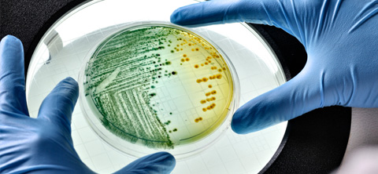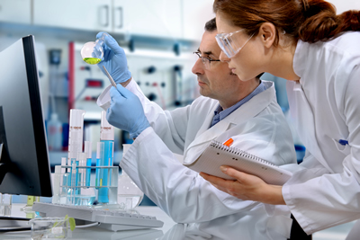

What is the Biotech Academy?

If you are interested in curing human diseases or producing food crops with more nutrition and higher yield to feed more people, biology research and product development, medicine, nursing, bioengineering, or genetics, the Biotech Academy may be for you!

The San Marin STEM Biotech academy is a college and career prep pathway focused on biotechnology. Students learn about basic biotechnology lab techniques, biotech products and the biotech industry, bioethics and careers in biotechnology. They will have work based learning opportunities like guest speakers, field trips, job shadowing and internships. Biotech 1&2 will be articulated with Introduction to Biotechnology at College of Marin and Solano Community College so students will get college credit for taking these classes at San Marin. Biotech Academy graduates will be prepared to enter a 4 year college or a 2 year certificate program at a community college.

So what will you learn in the Biotech Academy?
- Biotechnology and why it is important to our society, bioethics and how biotech products are developed
- Basic laboratory skills including using micropipets, balances and other lab equipment
- DNA isolation and manipulation, gel electrophoresis, PCR
- Grow bacteria cells and make them glow-in-the-dark
- Protein isolation and manipulation
- Prepare solutions for lab experiments
- Experimental design, procedures, data analysis and presentation
- Lab safety and techniques
- Conduct scientific research
- Internships, guest speakers, job shadowing
- Resume writing, interview skills and job skills

Who teaches the classes?
Dr. LaFevre-Bernt (Dr. L.-B.)

College Credit:
- Introduction to Biotechnology at COM
- There is a college course on Internship experiences created in conjunction with our program which some of our students attend. Students will work closely with other students, internship mentors and their teacher.

